Birla Institute of Technology and Science

Pilani

A REPORT ON

Smart Lighting System



HEMANTH V ALLURI 2017A7PS1170P

RAMACHANDRAN SHANKAR 2017A7PS1171P

ROSHAN ROY 2017A7PS1172P

PRAVEEN RAVIRATHINAM 2017A7PS1174P

SUBMITTED TO Dr. P. Mishra

GROUP NO: 106 PROBLEM NO: 14

INDEX

1. Problem Statement
2. Assumptions
3. Brief User Guide
4. List of Hardware Components Used
5. Address Mapping of Memory and I/O Devices
6. Flowchart of the Logic/Code
7. Code
8. Circuit Diagram
9. References

PROBLEM STATEMENT

Problem statement 14:

System to be Designed: Smart Lighting System

Description: This is a lighting system for a conference room. On detection of a person the door is automatically opened/closed. As the seats get filled the light should be turned on. The rows are filled from row1 onwards. There are 3 lights per row. As each row begins to get filled the lights get turned on as each rows empties completely the light gets turned off. You can assume there are atleast 6 rows. The system should also display the number of people in the room on a LCD display.

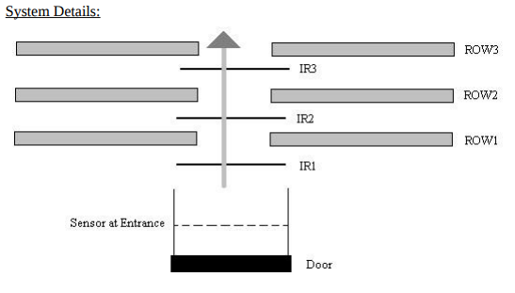

ASSUMPTIONS

1. There is only entry door to the conference room.
2. The same door is used for exit as well.
3. Only one person can enter at a time.
4. Only one person can exit at a time.
5. There is a gap of ~5 seconds between any two people’s movements across the door.
6. There are 2 sensors on either side of the door.
7. Each row has 3 lights .
8. If the row has even a single person all the lights should still turn on.
9. People get seated from row 1 onwards and exit from only last occupied row. i.e. a person cannot exit from nth row if (n+1)th row has a person.
10. If there are people present in the nth row that means all n rows are lighted up.
11. Maximum capacity of the conference room is 30; 6 rows with each row capable of seating 5 people.

BRIEF USER GUIDE

This system design is meant to be extremely simple in terms of user interaction. There are only 2 inputs to the system. On each side of the sliding door to the conference room, there is a pressure plate the user will step over (modelled as push buttons in the model circuit). After stepping on the exterior pressure plate the sliding door will open within a 1-2 second interval. After the sliding door opens, the user will be allowed to step in and over the interior pressure plate (within about 2-3 seconds) which will confirm that the user entered. After a 5 second delay the door will then close, following which another user may enter or leave. Exiting follows a similar procedure but with the user stepping on the interior pressure plate first, then the exterior pressure plate.

LIST OF HARDWARE COMPONETS USED

|  |  |  |
| --- | --- | --- |
| CHIP / DEVICE | QUANTITY | USE |
| 8086 Microprocessor | 1 | Central processing unit. |
| 6116 – Ram 2K | 2 | Random access memory which contains [DS,SS] |
| 2732 – ROM 4K | 2 | Read only memory which contains entire code [CS] |
| 74LS373 OCTAL LATCH | 1 | For latching the address provided by the 8086. |
| 74LS138 | 1 | 3-to-8 Decoder/Demultiplexer. |
| 8255 PPI | 2 | PPI for connecting to peripheral components. |
| LED | 18 | Used for lighting up rows. |
| L293D | 1 | The driver for the bipolar stepper motor. [<http://www.ti.com/lit/ds/symlink/l293.pdf>] |
| 7 SEG-COM-CATHODE | 2 | Used for displaying number of people in the room. |
| BIPOLAR STEPPER MOTOR | 1 | Used for controlling opening and closing of door. |
| 4511 BCD to 7SEG DECODER | 2 | Decoders for the 7 segment displays. |
| NAND | 1 | Logic. |
| OR | 9 | Logic. |
| NOT | 5 | Logic. |
| AND | 1 | Logic. |
| 100 ohm RESISTANCE | 2 | Logic. |
| PUSH BUTTONS | 2 | These are the two sensors on either side of the door |

ADDRESS MAPPING OF DEVICES

MEMORY MAPPING:

The system uses 4KB of RAM and 8KB of ROM. RAM consists of two 2K chips and ROM

consists of 4K chips. They are organized into odd and even bank to facilitate both byte and word

size data transfers.

Read Only Memory: Starting Address: 00000h, Ending Address: 01FFFh

Random Access Memory: Starting Address: 02000h, Ending Address: 02FFFh

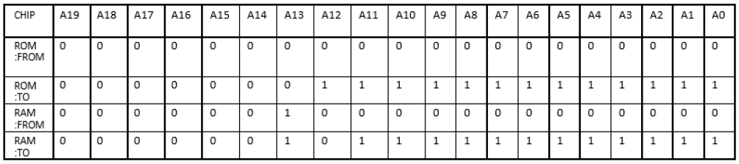

I/O MAPPING:

PPI1 – Pressure Plates (Push Buttons), Bipolar Stepper Motor Control, 7SEG Display

PORTA - 0000h

PORTB - 0002h

PORTC - 0004h

CONTROL REGISTER - 0006h

PPI2 – Lighting Array

PORTA - 0001h

PORTB - 0003h

PORTC - 0005h

CONTROL REGISTER - 0007h

FLOWCHART

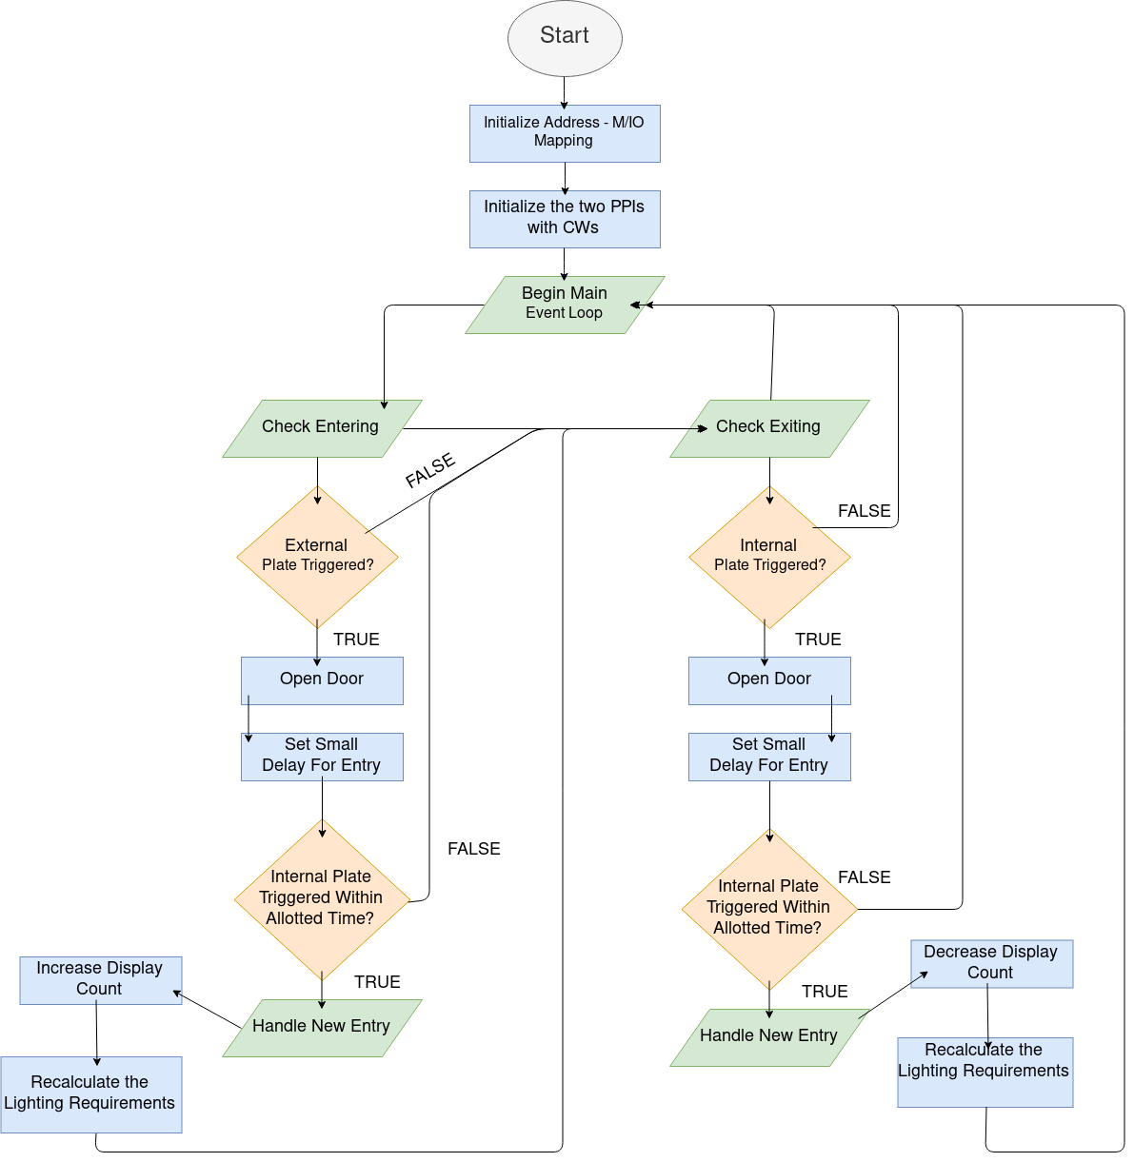

CODE

.MODEL TINY

.DATA

PORTA1 equ 0000h

PORTB1 equ 0002h

PORTC1 equ 0004h

CWREG1 equ 0006h

PORTA2 equ 0001h

PORTB2 equ 0003h

PORTC2 equ 0005h

CWREG2 equ 0007h

.CODE

.STARTUP

init:

ORG 0000h

; This register will serve as internal memory and store the number of people in the room.

MOV dl, 00h

; Set up the first PPI to read from Port A and write to Port B and Port C.

MOV al, 10010000b

OUT CWREG1, al

; Set up the second PPI to write to Port C [each output line is a row of 3 lights].

MOV al, 10010010b

OUT CWREG2, al

; "main" serves as our event loop and the functions check_entry and check_exit will handle the rest.

main:

CALL check_entry

CALL check_exit

JMP main

delay PROC NEAR

; A small timed delay. The caller should set CX before calling.

delay1:

NOP

DEC cx

JNE delay1

RET

delay ENDP

update_display PROC NEAR

; Update the 2 7SEGs to display the number of people in the room.

MOV bl, 10d

MOV ax, dx

DIV bl ; al: quotient, ah: remainder

MOV bl, ah

SHL ax, 4

ADD al, bl

OUT PORTC1, al

RET

update_display ENDP

incr_cnt PROC NEAR

; Increase the count value and update the display.

INC dl;

CALL update_display;

CALL light_rows

RET

incr_cnt ENDP

decr_cnt PROC NEAR

; Decrease the count value and update the display.

DEC dl;

CALL update_display;

CALL light_rows

RET

decr_cnt ENDP

open_door PROC NEAR

; Open the door by turning the stepper motor to 180deg.

MOV al, 00000001b

OUT PORTB1, al

RET

open_door ENDP

close_door PROC NEAR

; Close the door by turning the stepper motor to 0deg.

MOV al, 00000010b

OUT PORTB1, al

RET

close_door ENDP

check_entry PROC NEAR

; Check to see if the external pressure sensor has been triggered.

IN al, PORTA1

CMP al, 00000001b

JNE check_entry4

; Open the door once the external pressure sensor has been triggered.

CALL open_door

MOV cx, 0FFFFh

CALL delay

; Check to see if the internal pressure sensor has been triggered. Provide a small window of time for entry.

MOV cx, 0FFFFh

check_entry1:

IN al, PORTA1

CMP al, 00000010b

JE check_entry2

DEC cx

JNZ check_entry1

JMP check_entry3

check_entry2:

; If the person entered then the count should be incremented.

CALL incr_cnt

check_entry3:

; Close the door.

CALL close_door

check_entry4:

RET

check_entry ENDP

check_exit PROC NEAR

; Check to see if the external pressure sensor has been triggered.

IN al, PORTA1

CMP al, 00000010b

JNE check_exit4

; Open the door once the external pressure sensor has been triggered.

CALL open_door

MOV cx, 0FFFFh

CALL delay

; Check to see if the internal pressure sensor has been triggered. Provide a small window of time for entry.

MOV cx, 0FFFFh

check_exit1:

IN al, PORTA1

CMP al, 00000001b

JE check_exit2

DEC cx

JNZ check_exit1

JMP check_exit3

check_exit2:

; If the person exited then the count should be decremented.

CALL decr_cnt

check_exit3:

; Close the door.

CALL close_door

check_exit4:

RET

check_exit ENDP

light_rows PROC NEAR

; Check to see how many people are in the room (using the value in dl),

; then accordingly determine the number of rows that need to be lit up.

; start filling from ROW1 onwards.

; Our assumption is that the rows seat 5 people each.

; Thus the total capacity of the conference room is 5*6 = 30 people.

MOV al, 00d

CMP dl, 25d

JLE light_rows1

INC al

light_rows1:

SHL al, 1 ; Moving this up by one line would slightly improve speed (heuristic).

CMP dl, 20d

JLE light_rows2

INC al

light_rows2:

SHL al, 1

CMP dl, 15d

JLE light_rows3

INC al

light_rows3:

SHL al, 1

CMP dl, 10d

JLE light_rows4

INC al

light_rows4:

SHL al, 1

CMP dl, 05d

JLE light_rows5

INC al

light_rows5:

SHL al, 1

CMP dl, 00d

JE light_rows6

INC al

light_rows6:

OUT PORTC2, al

RET

light_rows ENDP

END

CIRCUIT DIAGRAM

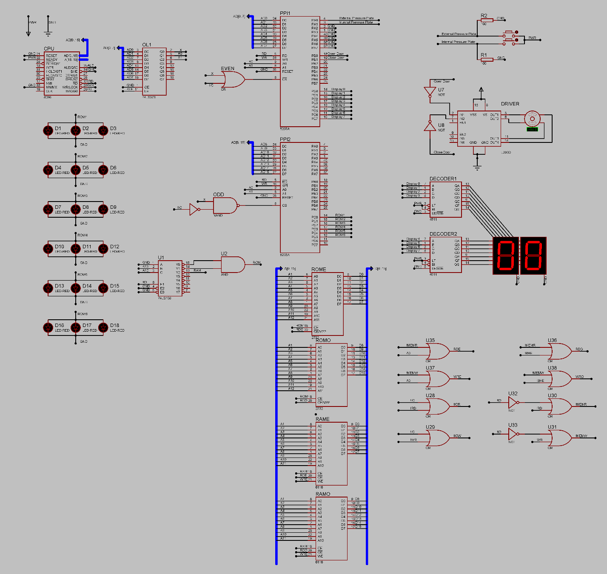

EXTRA REFERENCES

8086 PINOUT DIAGRAM:

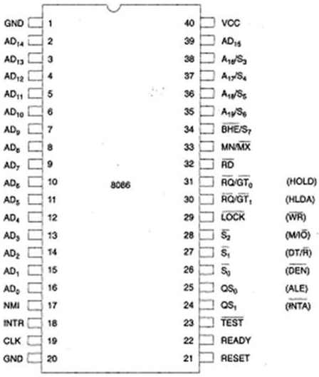

STEPPER MOTOR:

The data sheet and other information for the driver for the bipolar stepper motor can be found in the following link:

<http://www.ti.com/lit/ds/symlink/l293.pdf>